|  |
| --- |
| EE260 Assignment 1 |

**Submitted by:**

**Brandon Tomota**

Grade:



|  |  |
| --- | --- |
| Date of Submission: | 1/27/18 |
|  |  |

1. (5 pts) Problem 2.2 (a)-(c)
2. (5 pts) Problem 2.5 (a)-(f)
3. (5 pts) Problem 2.7 (a)-(b)
4. (5 pts) Problem 2.12 (a)-(b)
5. (5 pts) Problem 2.13
6. (10 pts) Problem 2.35

1)

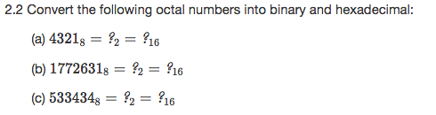

1. (4321)8 = 100|011|010|001 = (100011010001)2 = 1000|1101|0001 = (8D1)16
2. (1772631)8 = 001|111|111|010|110|011|001 = (1111111010110011001)2 = 0111|1111|0101|1001|1001 = (7F599)16
3. (533434)8 = 101|011|011|100|011|100 = (101011011100011100)2 = 0010|1011|0111|0001|1100 = (2B71C)16

2)

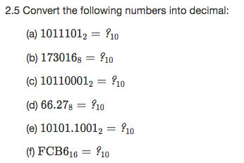

1. (1011101)2 = (1*26) + (0*25) + (1*24) + (1*23) + (1*22) + (0*21) + (1*20) = (93)10
2. (173016)8 = (1*85) + (7*84) + (3*83) + (0*82) + (1*81) + (6*80) = (62990)10
3. (10110001)2 = (1*27) + (0*26) + (1*25) + (1*24) + (0*23) + (0*22) + (0*21) + (1*20) = (177)10
4. (66.27)8 = (6*81) + (6*80) + (2*8-1) + (7*8-2) = (54.359375)10
5. (10101.1001)2 = (1*24) + (0*23) + (1*22) + (0*21) + (1*20) + (1*2-1) + (0*2-2) + (0*2-3) + (1*2-4) = (21.5625)10
6. (FCB6)16 = (15*163) + (12*162) + (11*161) + (6*160) = (64694)10

3)

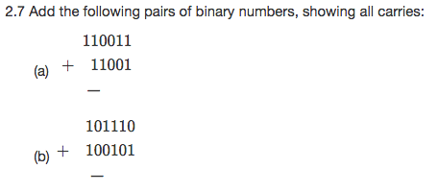

1. 11 1

110011

+11001

1001100

1. 1 11

101110

+ 100101

1010011

4)

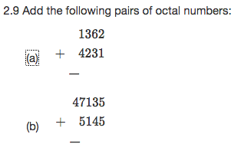

1. 1

1362

+4231

5613

1. 1 11

47135

+5145

54302

5)



Minimum distance = 2c + d + 1 (correct errors in up to c bits, detect errors in d additional bits)

Minimum distance d + 1 c = 0

Can detect up to d-bit errors

6)



n bit m bit

Ex: n = 5, m = 7

10101 (n-bit) = 1110101(m-bit)

By adding the two’s compliment of the n-bit number to the m-bit number, we can show the two are equivalent if the sum is zero

10101 01010 + 1 = 01011 (two’s compliment of the n-bit)

111111

1110101 (m-bit)

+01011 (two’s compliment of n-bit)

10000000

Ex: n = 3, m = 4

011 (n-bit) = 0011(m-bit)

By adding the two’s compliment of the n-bit number to the m-bit number, we can show the two are equivalent if the sum is zero

011 100 + 1 = 101 (two’s compliment of the n-bit)

0011 (m-bit)

+ 101 (two’s compliment of n-bit)

1000